**Project Requirement**

* **purpose of the project:**

The Appartment booking system is a web-based application aimed at simplifying the process of finding an apartment to lent for clients and apartment owners/managers. Developed using Thymeleaf for the frontend and Spring Boot for the backend, the platform caters to the needs of admins, apartment managers, and clients.

* **Expected Outcomes:**
  + Appartment availability: Managers can add apartments, view list of their appartments, view booked appartments.
  + Appartment booking: customers can search for specific city and see the available appartments in that city, be able to book one they want, and also provide their phone number for payment.
  + Secure Access: Login with protected routes ensures secure access for authorized users.
* **Specific Constraints or Limitations:**
  + Time Constraints: The project was supposed to be completed within 3 weeks
  + Security constraints:
    - File Upload Security: Need to Implement file scanning mechanisms to detect and prevent potential threats.
  + Scalability limitation: Handling an increased number of customers may pose challenges for apartment managers.

**Project Plan**

* **scope of the project:**
  + The project encompasses the development of a web-based assignment submission platform using Thymeleaf and Spring Boot.
* **source code:**
  + The source code for the project is hosted on GitHub:
    - Backend: https://github.com/vumurerwa/AppartmentBookingSystem
    - Frontend: https://github.com/vumurerwa/AppartmentBookingSystem
    - **Database schema**
* **Table definitions**

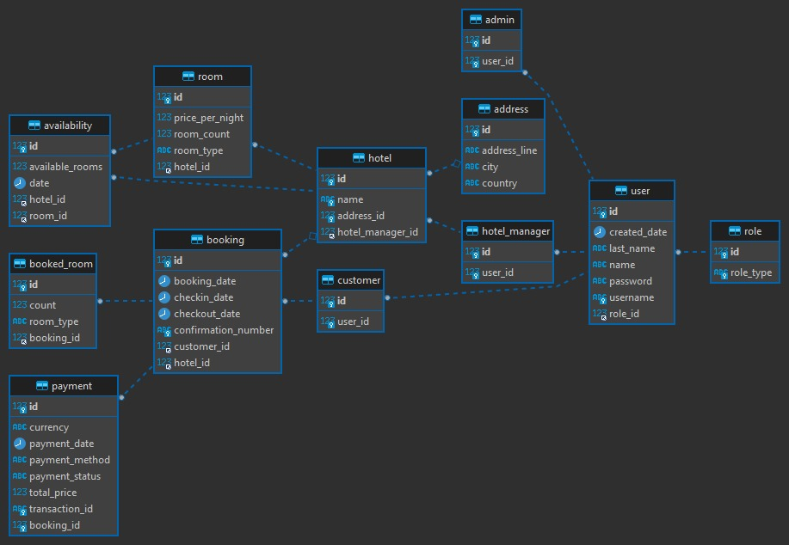

**User Documentation**

* **Appartment availability:**
  + Managers can log in and add appartments, specifying details(available rooms,location), view their appartments and view booked assignments.
* **Appartment booking:**
  + Customers can search for a city and see all available appartments in that city and be able to book the one they one and provide their phone number for making the payment.
* **Login Credentials:**
  + Admin:  
    - Username - [vixya@gmail.com](mailto:vixya@gmail.com), - Password – 123456

**Technical Documentation**

* **Architecture**
  + The application follows a client-server architecture, with Thymeleaf handling the frontend and Spring Boot serving as the backend.
* **Implementation Details:**
  + Frontend:
    - THYMELEAF
  + Backend:
    - JAVASCRIPT
    - SPRING BOOT
  + Database:
    - MYSQL
  + Dependencies:
    - Spring Boot Starter Web, Spring Boot Starter Data JPA,